Assignment 3: Lane Detection using
Edge Detection and Hough Transform
Course: Computer Vision
Student Name: Nguyen Thi Thanh Mai
Student ID: 2202104
GitHub: https://github.com/mayyaa824/Computer-Vision_220104
1. Objective
The goal of this assignment is to build a lane detection program that works like how self-driving cars find lane lines on the road. The program reads 10 road images and draws the detected lane lines on each image. Two main techniques are used: the Canny Edge Detector to find edges in the image, and the Hough Transform to find straight lines from those edges.
2. Methodology
Each image goes through the following steps one by one:
Step 1 — Grayscale Conversion: The color image is converted to grayscale (black and white). This makes it easier and faster to detect edges since we only need brightness, not color.
Step 2 — Gaussian Blur: A 5x5 blur is applied to smooth out the image slightly. This helps remove small random noise so the edge detector does not pick up unwanted details.
Step 3 — Canny Edge Detection: The Canny algorithm looks for areas in the image where brightness changes sharply — these are edges. It uses two threshold values: low = 50 and high = 150. If a threshold is too low, too many false edges appear from road texture and shadows. If too high, real lane edges get missed. After testing several values, 50 and 150 gave the best and cleanest results.
Step 4 — Region of Interest (ROI) Masking: Not all edges in the image are useful — edges from the sky, trees, or roadside cars are not lane lines. A trapezoid-shaped mask is applied to keep only the bottom 40% of the image (the road directly ahead) and block out everything else.
Step 5 — Probabilistic Hough Transform: The Hough Transform scans the edge image and finds straight lines by grouping edge points that line up together. The parameters control how many votes a line needs to be accepted, its minimum length, and the maximum gap allowed between two segments before they are treated as separate lines.
Step 6 — Lane Line Averaging: The Hough Transform often returns many short segments instead of one clean line. These segments are split into two groups — left lane and right lane — based on their slope direction and position. Then all segments on each side are averaged into a single smooth line that runs from the bottom of the image up to the horizon.
Step 7 — Visualization: The two final lane lines are drawn in green on the original image and saved to the output folder. A red circle is also drawn at the center point between the two lanes as part of the optional extension.
3. Parameter Settings
The table below summarizes all parameter values used in the final implementation:
Parameter | Value | Description
Canny Low Threshold | 50 | Weak edge threshold
Canny High Threshold | 150 | Strong edge threshold
Gaussian Kernel | (5, 5) | Blur kernel size
Hough Vote Threshold | 30 | Minimum votes to detect a line
Min Line Length | 50 px | Shortest line segment to keep
Max Line Gap | 100 px | Max gap between segments to join
ROI Top Boundary | 60% | Top of the region-of-interest mask
4. Results
The program was tested on 10 real road images taken from a dashcam-style angle. 9 out of 10 images had 2 lanes detected successfully. Image 4 only had 1 lane detected because it was taken from an unusual angle under a bridge. Below are all 10 output images with the detected lanes drawn in green and the lane center marked in red.
Figure 1: Image 01
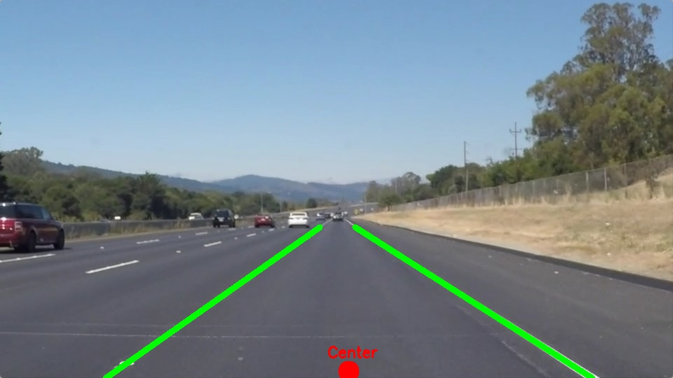
Figure 2: Image 02
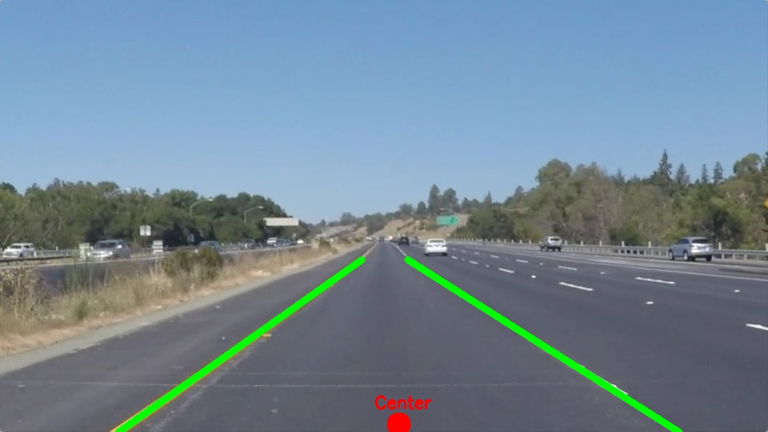
Figure 3: Image 03
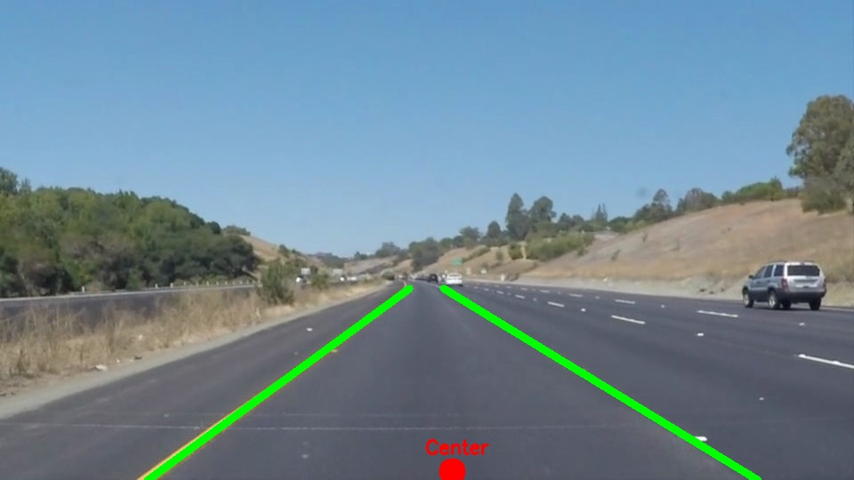
Figure 4: Image 04
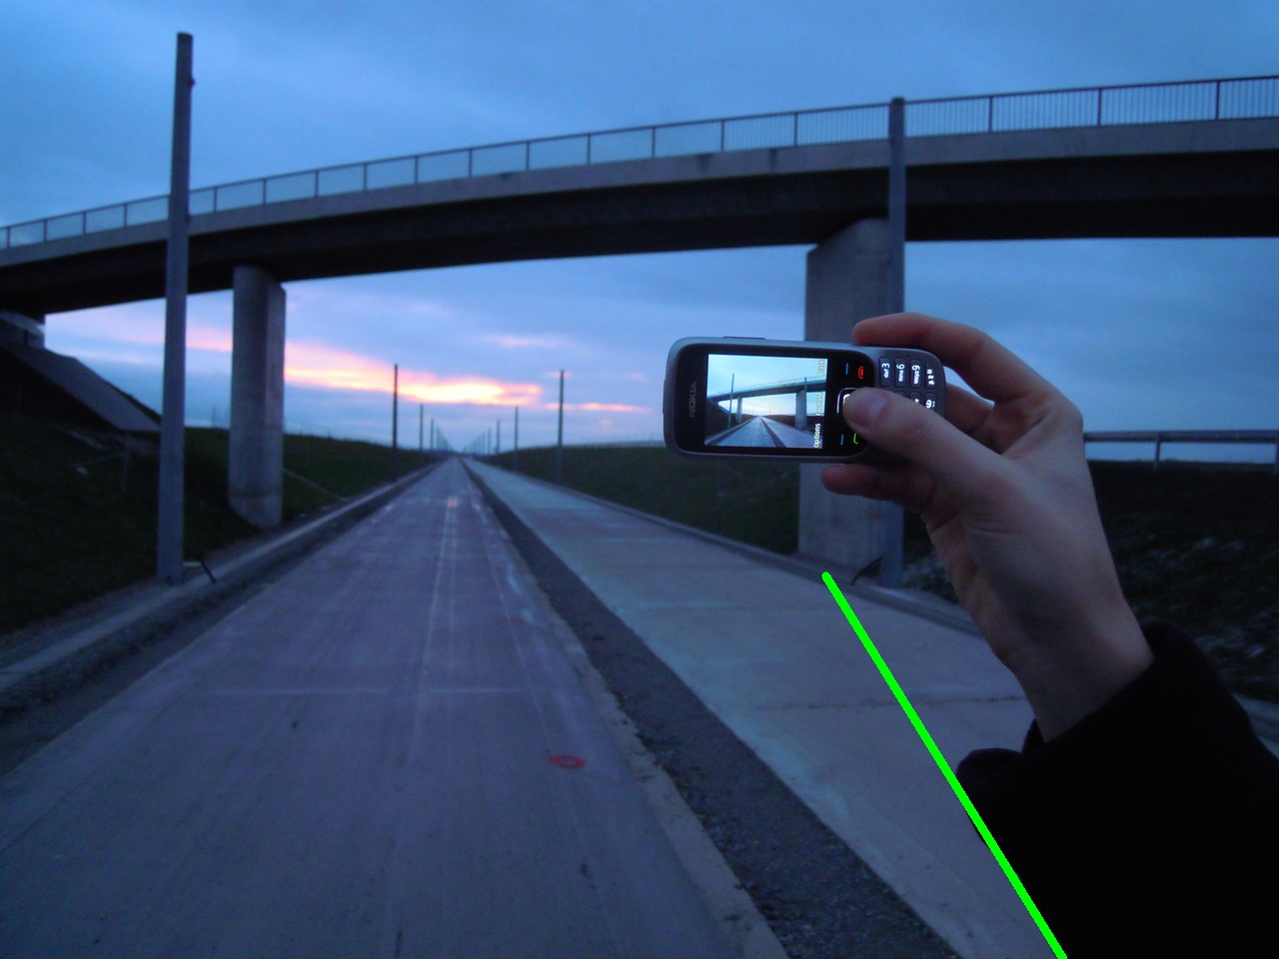
Figure 5: Image 05
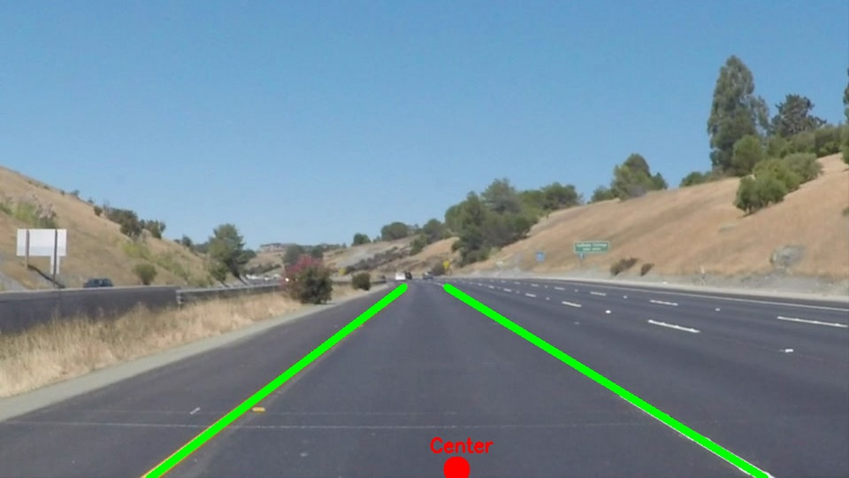
Figure 6: Image 06
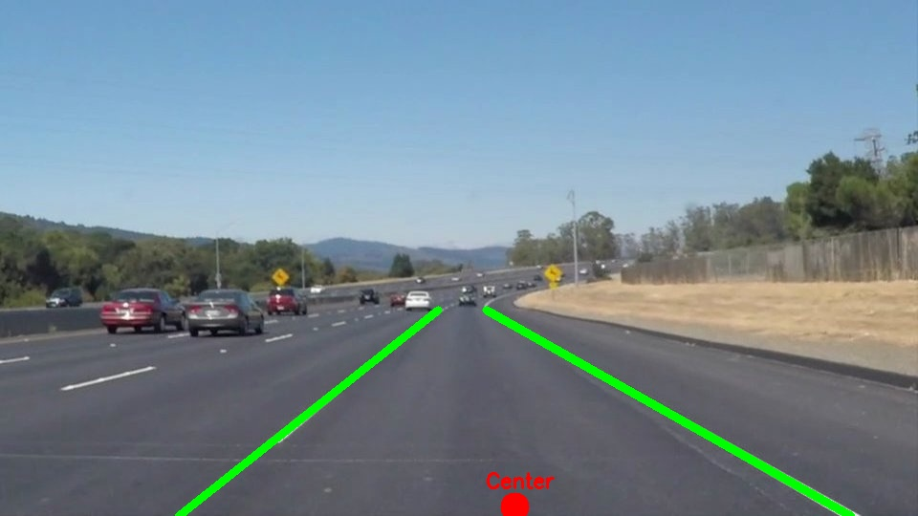
Figure 7: Image 07
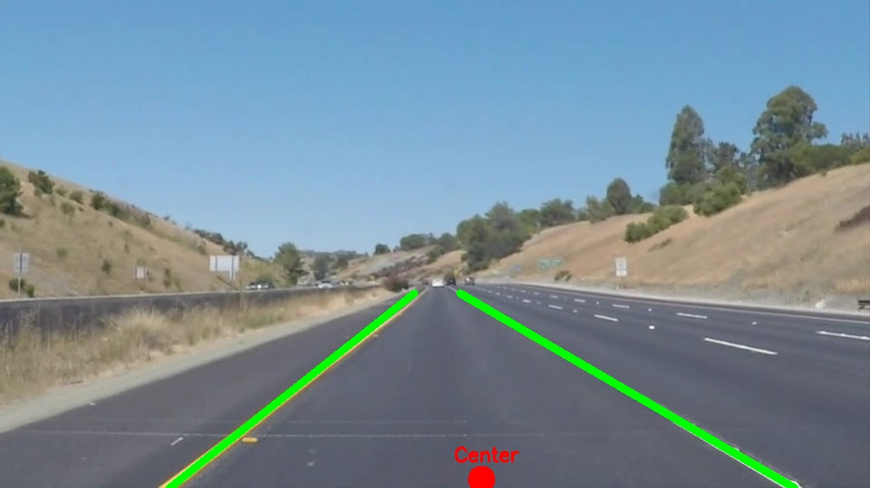
Figure 8: Image 08
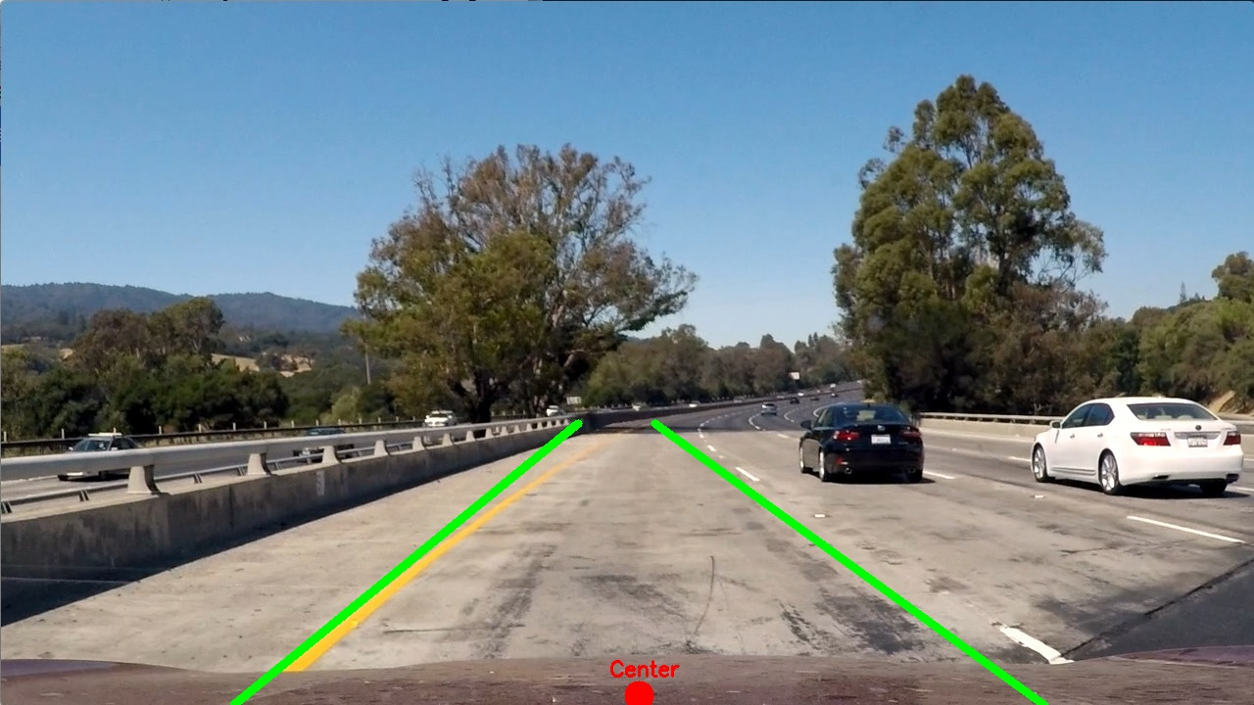
Figure 9: Image 09
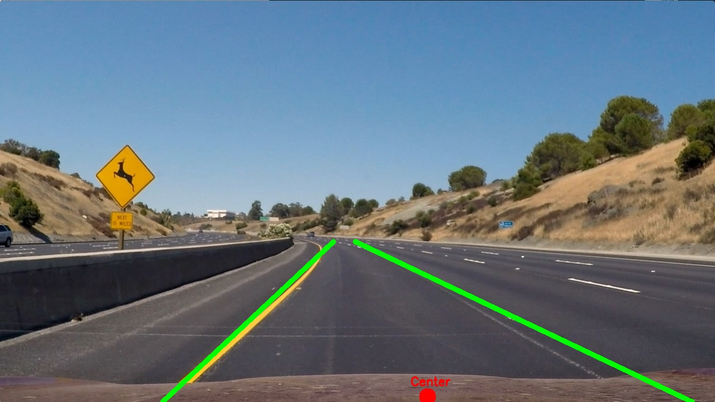
Figure 10: Image 10
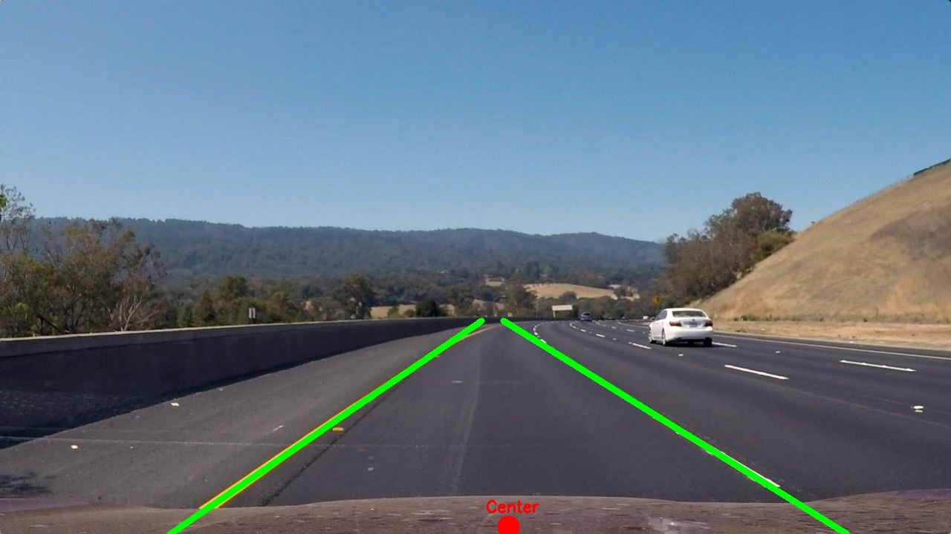
5. Challenges and Solutions
Canny threshold tuning: Finding the right threshold values took several tries. When the thresholds were too low, the detector picked up too many false edges from road texture, shadows, and car surfaces. When too high, the actual white or yellow lane lines were missed. After testing different combinations, 50 and 150 gave the cleanest results across most images.
Too many lines from Hough Transform: At first, the Hough Transform detected many short line segments from road cracks and surface texture. To fix this, the minimum line length was increased so only longer segments were kept. Lines that were nearly flat (horizontal) were also removed since real lane lines always have a noticeable angle.
Setting the right ROI size: The trapezoidal mask needed to be the right size. If too wide, it caught edges from guardrails and trees on the side. If too narrow, it missed parts of the lanes. Setting the top of the mask at 60% down the image worked well for all 10 images without needing different settings for each one.
Unusual camera angle in Image 4: Image 4 was taken from under a bridge where the road perspective looked different from the other images. Only one lane line was clearly visible. The program handled this correctly by detecting 1 lane instead of crashing or giving a wrong result.
6. Bonus Point — Lane Center Detection
As an optional extra, the program also finds and marks the center of the lane in each image.
How it works: after detecting the left and right lane lines, the program looks at the bottom end of each line (the closest point to the car). It then calculates the midpoint between these two points — this midpoint is the center of the lane. A filled red circle is drawn at this location and labeled 'Center'.
Why this is useful: in a real self-driving car system, knowing the lane center helps the car decide whether to steer left or right to stay in the middle of the lane. If the car's camera is at the center of the car, comparing the detected center point to the middle of the image tells the system how far off-center the car currently is. For example, if the red dot appears to the left of the image center, the car is drifting left and should steer slightly right to correct its position.
In this assignment, the center is shown as a visual indicator on each output image to demonstrate the concept. The feature works correctly on all 9 images where both lane lines were detected.

